Development of temperature and relative humidity profiles from the Wasatch Front Ozone NAA for mobile source emissions modeling in MOVES
Mobile emissions modeling requires diurnal temperature and relative humidity (RH) profiles that are representative of the region of interest. Because the Wasatch Front experiences ozone exceedances sporadically throughout the summer months, a single profile is not representative an ozone event, and many months of meteorological data must be analyzed. For future SIP demonstrations, the months of May, June, July, and August (MJJA) of 2017 will be used. All of the meteorological data used in this analysis was acquired from the MesoWest data archives. Mesowest (mesowest.utah.edu) is a database of current and archived meteorological data from weather stations in the United States maintained by the University of Utah. The approach for developing temperature and RH profiles are described below.
To complete this analysis, the largest population center in each county was identified. Then, data from the nearest weather station was acquired from the MesoWest data Archives. The majority of the 29 counties had representative weather stations with data completeness >95% for MJJA of 2017. For counties that had incomplete or unreliable meteorological data, nearby stations of similar latitude and altitude were used to generate temperature and RH profiles. Table 1 indicates which counties are represented with meteorological data from stations > 50 km from the largest population center.
The meteorological data were then averaged to hourly time frequency to account for stations that reported data more frequently. Hourly data were grouped by month and averaged, creating an averaged diurnal profile for the entire month. Figures 1 and 2 show these profiles for July. Salt Lake City (lavender), Saint George (green), and Park City (plum) have heavier line widths for reference.

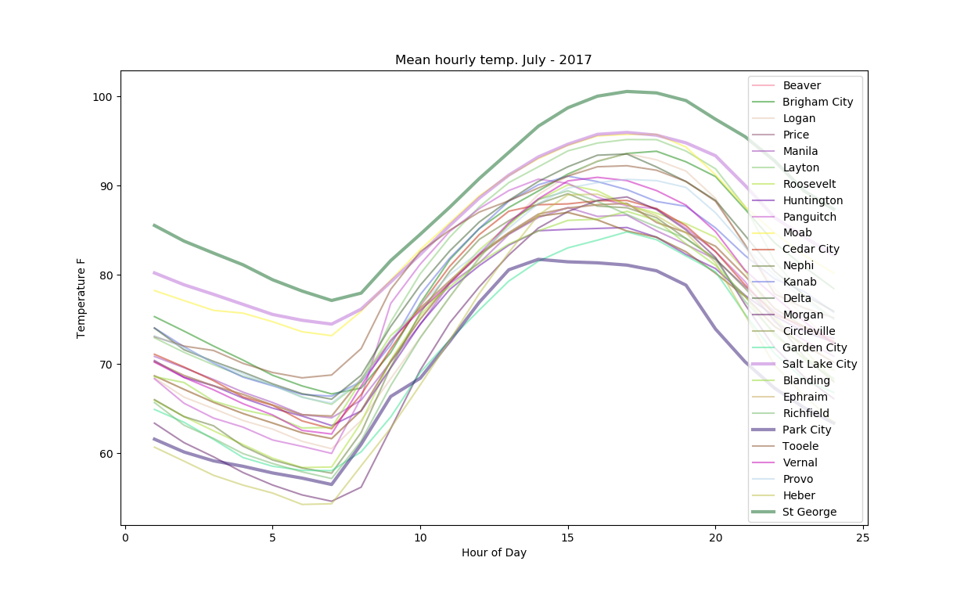
Figure 1: Temperature profile of an average day in July, 2017 for meteorological stations at each County's largest population center (or representative station as described in Table 1.)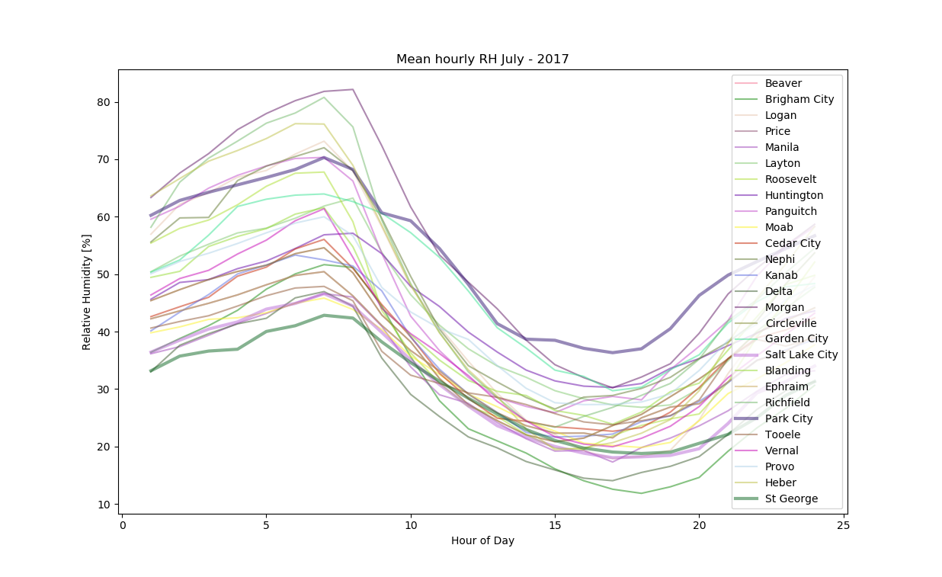
Figure 2: Relative humidity profile of an average day in July, 2017 for meteorological stations at each County's largest population center (or representative station as described in Table 1.)
MOVES zoneID | County | Largest City | City Elevation | Elevation of Station | Location of Station
90010 | Beaver | Beaver | 5860
490030 | Box Elder | Brigham City | 4301
490050 | Cache | Logan | 4446
490070 | Carbon | Price | 5813
490090 | Daggett | Manila | 6374 | 6731 | Near Dinosaur NM, Moffat County, CO
490110 | Davis | Layton | 4789 | 4245
490130 | Duchesne | Roosevelt | 5171
490150 | Emery | Huntington | 5843 | 5843 | Castle Dale, Emery County
490170 | Garfield | Panguitch | 6759 | 6200 | I-15 at Wildcat Ridge, Beaver County
490190 | Grand | Moab | 4026
490210 | Iron | Cedar City | 5581
490230 | Juab | Nephi | 5002
490250 | Kane | Kanab | 4970
490270 | Millard | Delta | 4755
490290 | Morgan | Morgan | 5069
490310 | Piute | Circleville | 6066 | 5941 | 1-15 at Beaver, Beaver County
490330 | Rich | Garden City | 5929
490350 | Salt Lake | Salt Lake City | 4226
490370 | San Juan | Blanding | 6001
490390 | Sanpete | Ephraim | 5500 | 5831 | Price Regional Airport, Price County
490410 | Sevier | Richfield | 5299 | 5224 | Venice, Sevier County
490430 | Summit | Park City | 7000
490450 | Tooele | Tooele | 4291
490470 | Uintah | Vernal | 5262
490490 | Utah | Provo | 4498
490510 | Wasatch | Heber | 5597
490530 | Washington | St George | 2872
490550 | Wayne | Loa | 7062 | 7151 | Ghost Rocks, Emery County
490570 | Weber | Ogden | 4440

